Time: 2 hr

Guidelines

Must read the problem statement thoroughly before start working .
Create java project using Eclipse only
Create all java classes in package “com.itech” in src folder of created java project
Must follow the class outline as shown in figure
Must follow java coding standards
Make sure your java project must be free from compilation error ,ie. zero compilation error .In case of any compilation error reported ,the project is rejected , will not considered for assessment.
Create a new workspace/folder with name PS-JAVA in C: /Users/Ur name
Select that workspace and Create java project with name PS_Name(eg. PS_Rohinth.zip)
Copy that project once you have completed to desktop,zip the folder ( eg. PS_Rohinth.zip), mail it

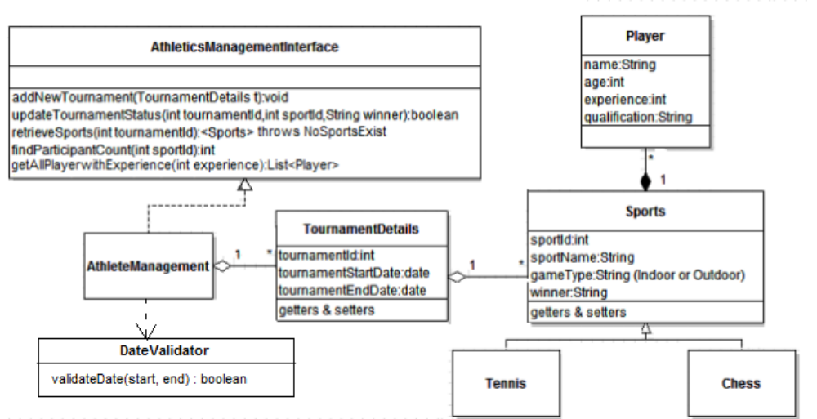

Athletics Management handles many tournaments. Each tournament contains many sports
events. Each sport is associated with many players. Write a java program to correctly implement
the required relationships and logic for the functions mentioned in the class diagram.

DateValidator
This is a utility class used to compare two dates. It will return a true
If the start less than or equal to end dates.
Otherwise it will return a false.
Need to validate the Tournament start and end date using this utility.

1. addNewTournament(T ournamentDetails t):void
This method adds the new tournament details to the existing list of tournaments.If the
tournament already exists throw TournamentAlreadyExists exception.

2. updateTournamentStatus(int tournamentId,int sportId,String winner):boolean
This method updates the winner status for the given sport under the given tournament.If the
given tournament doesnot extist throw InvalidTournament exception.

3. retrieveSports(int tournamentId):<Sports> throws NoSportsExist
This method retrieves the list of all sports where the winner is not declared in the given
tournament. It will throw an exception if no Sports found.

4. findParticipantCount(int sportId):int
This method finds out the total number of participants in a given tournament.
Create SportsManagementDemo

This method need to write in the paper.
5. getAllPlayerwithExperience(int experience):List<Player>
This method finds the list of all player with experience greater than or equal to the mentioned experience.

Zip Procedure:

1. In eclipse right click on your project.

2. Select copy, then on desktop paste it.

3. Now, on desktop your project folder will be available. Right click that folder and select, send to -> compressed folder.

4. Now you can find compressed file (zip) of your project folder.

